RFID System Identifies Solar Cell Carriers
Chinese solar cell manufacturer uses Turck's RFID system to increase the quality and efficiency of its production

A Chinese system integrator is automating the quality assurance and traceability of solar cell production for its customers with RFID technology. The company chose Turck's BL ident RFID system, which can be integrated smoothly into existing plants. This solution enables real time control and monitoring of the individual production steps, supplies reliable data for the production management and allows comprehensive, timely and precise monitoring on site.
Metadaten
Keywords:
Transfer Description:
URL/Dateiname CMS:
Social Post: �⚡ Quality assurance and traceability in solar cell production – Turck's BL ident RFID system enables real-time control and monitoring of the individual production steps, provides reliable data for quality management and creates a sound basis for decision-making.
#Turck #GlobalAutomationPartner #RFID #TrackAndTrace #Qualityassurance #Qualitymanagementsystems #Photovoltaic
The photovoltaic industry is playing a key role worldwide as part of the energy transition. Solar cell manufacturers are faced with the challenge of consistently producing good quality and increasing their production output – while maintaining or reducing costs. But where do the errors mostly occur in the production process? At which points is an adaption worthwhile? In order to find well-founded answers to these questions, manufacturers need a full and seamless collection of production data.

A Chinese system integrator was therefore commissioned by a manufacturer to collect this data for its solar cell production in order to provide a basis to make well-founded production decisions. An automated solution was required to guarantee smooth production and quality control. The customer decided as a result to use RFID to implement data acquisition and processing as efficiently as possible throughout the entire production process.

Production tracking by wafer carrier detection
Quality assurance and control play an essential role in the production of solar cells. The complex manufacturing requires the precise allocation of production batches right down to the individual silicon wafer. The solar cell wafers are transported between the production steps and stored in special wafer cassettes. The installation of RFID tags provides each wafer carrier with a unique identification code to which a production order is assigned.

Read/write heads are installed at the stations of each process step in order to capture the information of the tags as soon as they enter their read range. An RFID data acquisition system was set up based on the collected data, which feeds the information automatically to the system and interacts with it in real time.

RFID solution impresses integrator
Its modular and versatile structure enables Turck's BL ident RFID solution to be adapted easily to any application and integrated in existing plants. Standard software modules are available for easy system integration and commissioning.

Turck's TBEN RFID modules offer three Ethernet protocols with Profinet, Ethernet/IP and Modbus TCP, which are compatible with the controllers of many manufacturers. In this way, the user is able to reduce the number of different variants in the warehouse and thus also reduce the product inventories to be kept on hand for each project, thus saving considerable costs.

The tags were robust enough for solar cell production and impressed in the specific project. The tags with protection to IP68 can be stored for up to 100 hours at temperatures up to 140 degrees. Thanks to the 16 kilobyte data buffer of the TBEN RFID interface, the wafer carriers no longer have to wait in front of the read/write devices until all read/write operations have been completed. This means that the manufacturer can achieve a higher production speed – without any loss in quality. The TBEN module also offers an integrated switch that enables a line or ring topology to be set up and thus simplifies network cabling.

All these features impressed the customer and gave him a significant improvement in the efficiency of his production. “By using Turck's RFID solution, the company is now able to track all production processes fully and ensure a high level of process quality. The RFID system not only improves the flow of information but also provides a reliable basis for making well-founded decisions for future optimizations,” the system integrator concludes.

Author: Lin Qiang, marketing & product management department, Turck (Tianjin) Sensors Co.

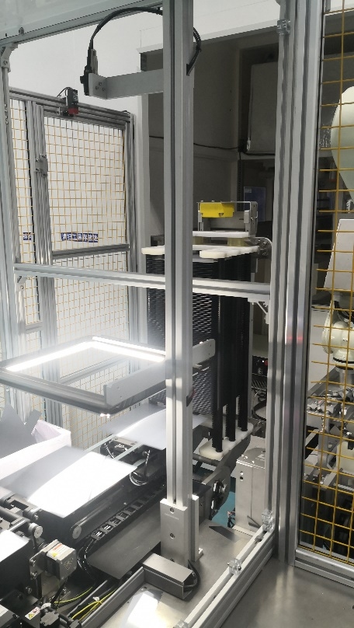
Sol_01: The read/write head detects the RFID tags in the wafer carriers

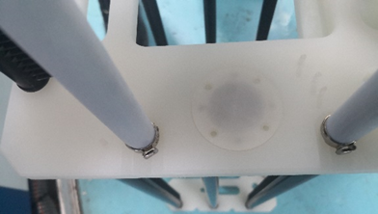
Sol_02: The integrated RFID tag allows each wafer carrier to be identified uniquely and assigned to a production order

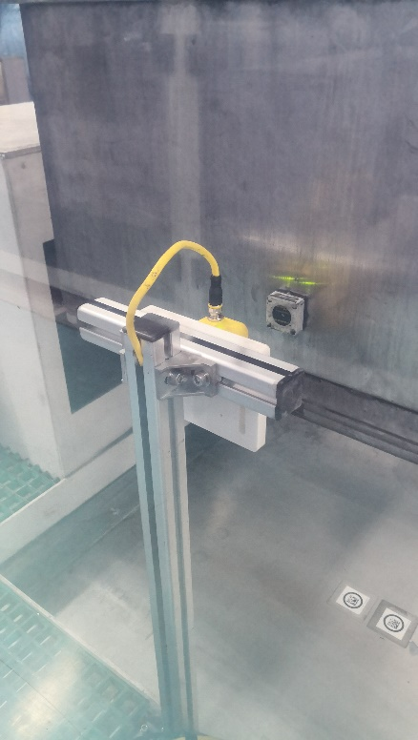
Sol_03: HF read/write heads at each process station ensure reliable data acquisition

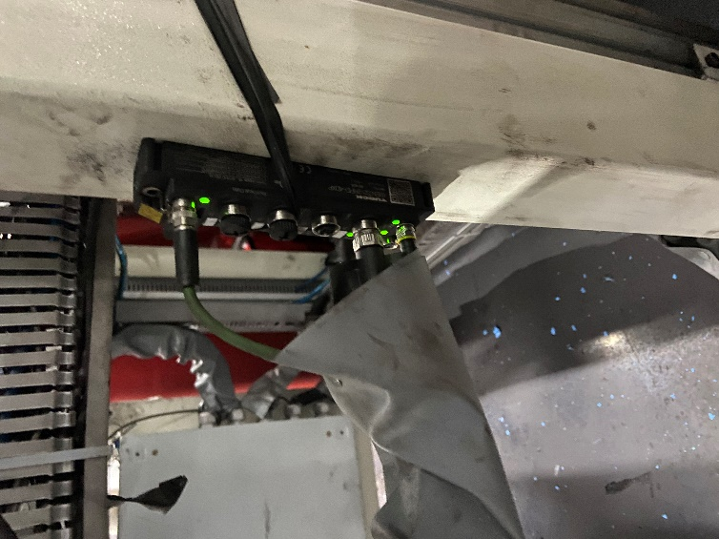

Sol_04: With its 16 kilobyte data buffer, Turck's TBEN S RFID module offers impressive performance

PRESSE-KONTAKT
Klaus Albers
Leiter Marketing Services & Public Relations
Telefon: 0208 4952-149
Mobil: 0160 93950359
Mail: klaus.albers@turck.com
Web: www.turck.com/presse

LESER-KONTAKT
Hans Turck GmbH & Co. KG
Witzlebenstraße 7
45472 Mülheim an der Ruhr
Telefon: 0208 4952-0
Mail: more@turck.com
Web: www.turck.com

